Experiment 39

PATTERN SEARCHING

AIM: To study and understand the formal design, specification and modelling of Pattern Searching / Text Searching using Finite State Machine

FINITE STATE MACHINE (FSM) :

A Finite State Machine is an abstract model of a system (physical, biological, mechanical, electronic, or software. Key components of a FSM are
- A finite number of states which represent the internal “memory” of the system
by implicitly storing information about what has happened before
- Transitions which represent the “response” of the system to its environment. Transitions depend upon the current state of the machine as well as the current input and often result in a change of state.

CONCEPTUAL MODEL OF THE PATTERN MATCHING SYSTEM :

Pattern searching is an important problem in computer science. When we search for a string in notepad / word file or browser or database, pattern searching algorithms are used to show the results. Finite Automata (FA) can also be used for pattern searching. In FA-based pattern searching algorithm, we preprocess the pattern and build a 2D array that represents a Finite Automata. Construction of the FA is the main tricky part of this algorithm. Once this FA is built, the searching is simple. In search, we simply need to start from the first state of the automata and the first character of the text. At every step, we consider the next character of text, look for the next state in the built FA and move to a new state. If we reach the final state, then the pattern is found in the text. The time complexity of the search process is O(n).

FORMAL DEFINITION OF THE FINITE AUTOMATA

A Simple Example:

Suppose a text file consists of only a’s and b’s and the search is for the string “abba”.
The corresponding finite automata will be as follows:
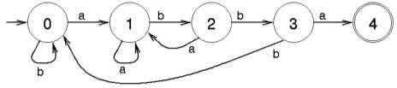

Start searching for the string from the initial state 0 and when the final state 4 is reached, the search is successful.

A Complex Example :

For example, let us design a Finite Automata for accepting the keywords “ezhil”, “hills” and “lssbus” in a text file. The Nondeterministic Finite Automata (NFA) can be built quickly for the given problem. Based on the number of keywords and its length, the size of the NFA may vary.
Formal definition of the NFA can be written as N = (Q, 𝚺, δ, q0, F)
where
- Q → set of states {1, 2, 3, 4, 5, 6, 7, 8, 9, 10, 11, 12, 13, 14, 15, 16, 17}
- 𝚺 → input alphabet {a, b, c, d, e, f, g, h, i, j, k, l, m, n, o, p, q, r, s, t, u, v, w, x, y, z}
- q0 → initial state. 1
- F → set of final states {6, 11, 17}
- δ → transition function which is shown below as transition diagram and table

Transition Diagram :
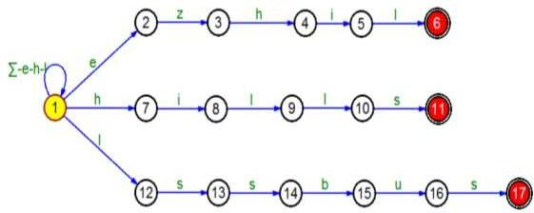
State Transition Table :
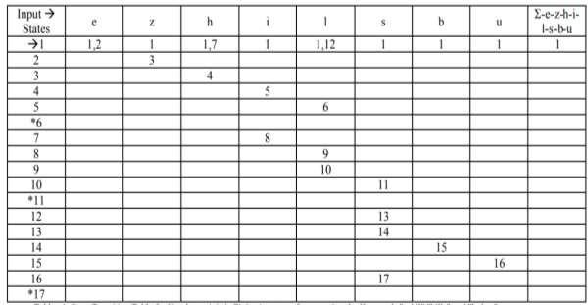

Sample Input :

If the given input is

That dr ezhilarasu umadevi went to nilgiri hills by lssbus. Ezhil visited many places in hills. On the way, he saw one flex which has the word ezhillssbus
Starting from the initial state, taking the input character by character, if one of the final states is reached, the input word will be accepted.

SAMPLE C PROGRAM :

// C program for Finite Automata Pattern searching Algorithm
#include<stdio.h> #include<string.h> #define NO_OF_CHARS 256

int getNextState(char *pat, int M, int state, int x)
{
// If the character c is same as next character
// in pattern,then simply increment state
if (state < M && x == pat[state]) return state+1; // ns stores the result which is next state
int ns, i;

// ns finally contains the longest prefix
// which is also suffix in "pat[0..state-1]c"

// Start from the largest possible value
// and stop when you find a prefix which is also suffix
for (ns = state; ns > 0; ns--)
{
if (pat[ns-1] == x)
{
for (i = 0; i < ns-1; i++)
if (pat[i] != pat[state-ns+1+i]) break;
if (i == ns-1)
return ns;
}
}

return 0;
}

/* This function builds the TF table which represents Finite Automata for a given pattern */

void computeTF(char *pat, int M, int TF[][NO_OF_CHARS])
{
int state, x;
for (state = 0; state <= M; ++state)
for (x = 0; x < NO_OF_CHARS; ++x)
TF[state][x] = getNextState(pat, M, state, x);
}

/* Prints all occurrences of pat in txt */

void search(char *pat, char *txt)
{
int M = strlen(pat); int N = strlen(txt);

int TF[M+1][NO_OF_CHARS]; computeTF(pat, M, TF);

// Process txt over FA.
int i, state=0;
for (i = 0; i < N; i++)
{
state = TF[state][txt[i]]; if (state == M)
printf ("\n Pattern found at index %d",

}
}

i-M+1);

// Driver program to test above function
int main()
{
char *txt = "AABAACAADAABAAABAA";
char *pat = "AABA"; search(pat, txt); return 0;
}

RESULT:

The conceptual model of the pattern searching system, the method for constructing NFA for the required keywords and searching for the required keywords in a text file are studied.

